Chapter 3
Interdependence and the Gains from Trade
MULTIPLE CHOICE
1. People who provide you with goods and services
a. are acting out of generosity.
b. are acting because they like you.
c. do so because they get something in return.
d. are required to do so by government.
ANSWER: c. do so because they get something in return.
TYPE: M SECTION: 1 DIFFICULTY: 1
2. A rancher can produce only hamburgers, and a farmer can produce only french fries. The rancher and the farmer both like both foods. They
a. cannot gain from trade.
b. could gain from trade under certain circumstances, but not always.
c. could gain from trade because each would enjoy a greater variety of food.
d. could gain from trade only if each were indifferent between hamburgers and french fries.
ANSWER: c. could gain from trade because each would enjoy a greater variety of food.
TYPE: M SECTION: 1 DIFFICULTY: 2
3. Regan grows flowers and makes ceramic vases. Jayson also grows flowers and makes vases, but Regan is better at producing both. In this case, trade could
a. benefit both Jayson and Regan.
b. benefit Jayson, but not Regan.
c. benefit Regan, but not Jayson.
d. not benefit Jayson nor Regan.
ANSWER: a. benefit both Jayson and Regan.
TYPE: M SECTION: 1 DIFFICULTY: 2
4. Without trade
a. a country is better off because it will become self-sufficient.
b. a country’s production possibilities frontier is also its consumption possibilities frontier.
c. a country can still benefit from international specialization.
d. more product variety is available in a country.
ANSWER: b. a country’s production possibilities frontier is also its consumption possibilities frontier.
TYPE: M SECTION: 1 DIFFICULTY: 2
5. With trade a
a. country is worse off because it becomes dependent on other countries.
b. country will produce a greater variety of goods and services to trade.
c. country’s consumption possibilities frontier can be outside its production possibilities frontier.
d. country will experience a lower unemployment rate.
ANSWER: c. country’s consumption possibilities frontier can be outside its production possibilities frontier.
TYPE: M SECTION: 1 DIFFICULTY: 2
6. A country’s consumption possibilities frontier can be outside its production possibilities frontier if
a. additional resources become available.
b. there is an increase in the level of technology.
c. the country engages in trade.
d. All of the above are correct.
e. Both a and b are correct.
ANSWER: c. the country engages in trade.
TYPE: M SECTION: 1 DIFFICULTY: 3
7. A production possibilities frontier will be linear and not bowed out if
a. no tradeoffs exist.
b. the tradeoff between the two goods is always at a constant rate.
c. unemployment is zero.
d. resources are allocated efficiently.
ANSWER: b. the tradeoff between the two goods is always at a constant rate.
TYPE: M SECTION: 1 DIFFICULTY: 2
8. The difference between production possibilities frontiers that are bowed out and those that are linear is that
a. bowed out production possibilities frontiers illustrate tradeoffs where linear production possibilities frontiers do not.
b. bowed out production possibilities frontiers show increasing opportunity cost where linear ones show constant opportunity cost.
c. bowed out production possibilities frontiers are the result of perfectly shiftable resources where linear production possibilities frontiers are not.
d. linear production possibilities frontiers illustrate real world conditions more than bowed out production possibilities frontiers.
ANSWER: b. bowed out production possibilities frontiers show increasing opportunity cost where linear ones show constant opportunity cost.
TYPE: M SECTION: 1 DIFFICULTY: 3
9. Which of the following is NOT correct?
a. Trade allows for specialization.
b. Trade is good for nations.
c. Trade is based on absolute advantage.
d. Trade allows individuals to consume outside of their individual production possibilities curve.
ANSWER: c. Trade is based on absolute advantage.
TYPE: M SECTION: 2 DIFFICULTY: 2
10. If labor in Mexico is less productive than labor in the United States in all areas of production,
a. neither nation can benefit from trade.
b. Mexico can benefit from trade but the United States cannot.
c. Mexico will not have a comparative advantage in any good.
d. both nations can benefit from trade.
ANSWER: d. both nations can benefit from trade.
TYPE: M SECTION: 2 DIFFICULTY: 2

Labor Hours Needed to Make 1 Pound of: | Pounds produced in 40 hours:

 | Meat | Potatoes | Meat | Potatoes
Farmer | 8 | 2 | 5 | 20
Rancher | 4 | 5 | 10 | 8

11. According to the table, the opportunity cost of 1 pound of meat for the farmer is
a. 1/4 hour of labor.
b. 4 hours of labor.
c. 4 pounds of potatoes.
d. 1/4 pound of potatoes.
ANSWER: c. 4 pounds of potatoes.
TYPE: M SECTION: 2 DIFFICULTY: 3
12. According to the table, the opportunity cost of 1 pound of meat for the rancher is
a. 4 hours of labor.
b. 5 hours of labor.
c. 5/4 pounds of potatoes.
d. 4/5 pound of potatoes.
ANSWER: d. 4/5 pound of potatoes.
TYPE: M SECTION: 2 DIFFICULTY: 3
13. According to the table, the opportunity cost of 1 pound of potatoes for the farmer is
a. 8 hours of labor.
b. 2 hours of labor.
c. 4 pounds of meat.
d. 1/4 pound of meat.
ANSWER: d. 1/4 pound of meat.
TYPE: M SECTION: 2 DIFFICULTY: 3
14. According to the table, the opportunity cost of 1 pound of potatoes for the rancher is
a. 4 hours of labor.
b. 5 hours of labor.
c. 5/4 pounds of meat.
d. 4/5 pound of meat.
ANSWER: c. 5/4 pounds of meat.
TYPE: M SECTION: 2 DIFFICULTY: 3
15. According to the table, the Farmer has an absolute advantage in
a. meat, and the Rancher has an absolute advantage in potatoes.
b. potatoes, and the Rancher has an absolute advantage in meat.
c. meat, and the Rancher has an absolute advantage in meat.
d. neither good, and the Rancher has an absolute advantage in both goods.
ANSWER: b. potatoes, and the Rancher has an absolute advantage in meat.
TYPE: M SECTION: 2 DIFFICULTY: 2
16. According to the table, the Rancher has an absolute advantage in
a. both goods, and the Farmer has a comparative advantage in meat.
b. meat, and the Farmer has a comparative advantage in potatoes.
c. meat, and the Farmer has a comparative advantage in neither good.
d. both goods, and the Farmer has a comparative advantage in potatoes.
ANSWER: b. meat, and the Farmer has a comparative advantage in potatoes.
TYPE: M SECTION: 2 DIFFICULTY: 3
17. According to the table, the Farmer has an absolute advantage in
a. potatoes, and the Rancher has a comparative advantage in meat.
b. meat, and the Rancher has a comparative advantage in potatoes.
c. neither good, and the Rancher has a comparative advantage in potatoes.
d. neither good, and the Rancher has a comparative advantage in meat.
ANSWER: a. potatoes, and the Rancher has a comparative advantage in meat.
TYPE: M SECTION: 2 DIFFICULTY: 3
18. According to the table, the Rancher has a comparative advantage in
a. neither good, and the Farmer has a comparative advantage in both goods.
b. both goods, and the Farmer has a comparative advantage in neither good.
c. meat, and the Farmer has a comparative advantage in potatoes.
d. potatoes, and the Farmer has a comparative advantage in meat.
ANSWER: c. meat, and the Farmer has a comparative advantage in potatoes.
TYPE: M SECTION: 2 DIFFICULTY: 3
19. According to the table, the Farmer and Rancher both could benefit by the Farmer specializing in
a. meat and the Rancher specializing in potatoes.
b. potatoes and the Rancher specializing in meat.
c. neither good and the Rancher specializing in both goods.
d. They cannot benefit by specialization and trade.
ANSWER: b. potatoes and the Rancher specializing in meat.
TYPE: M SECTION: 2 DIFFICULTY: 2

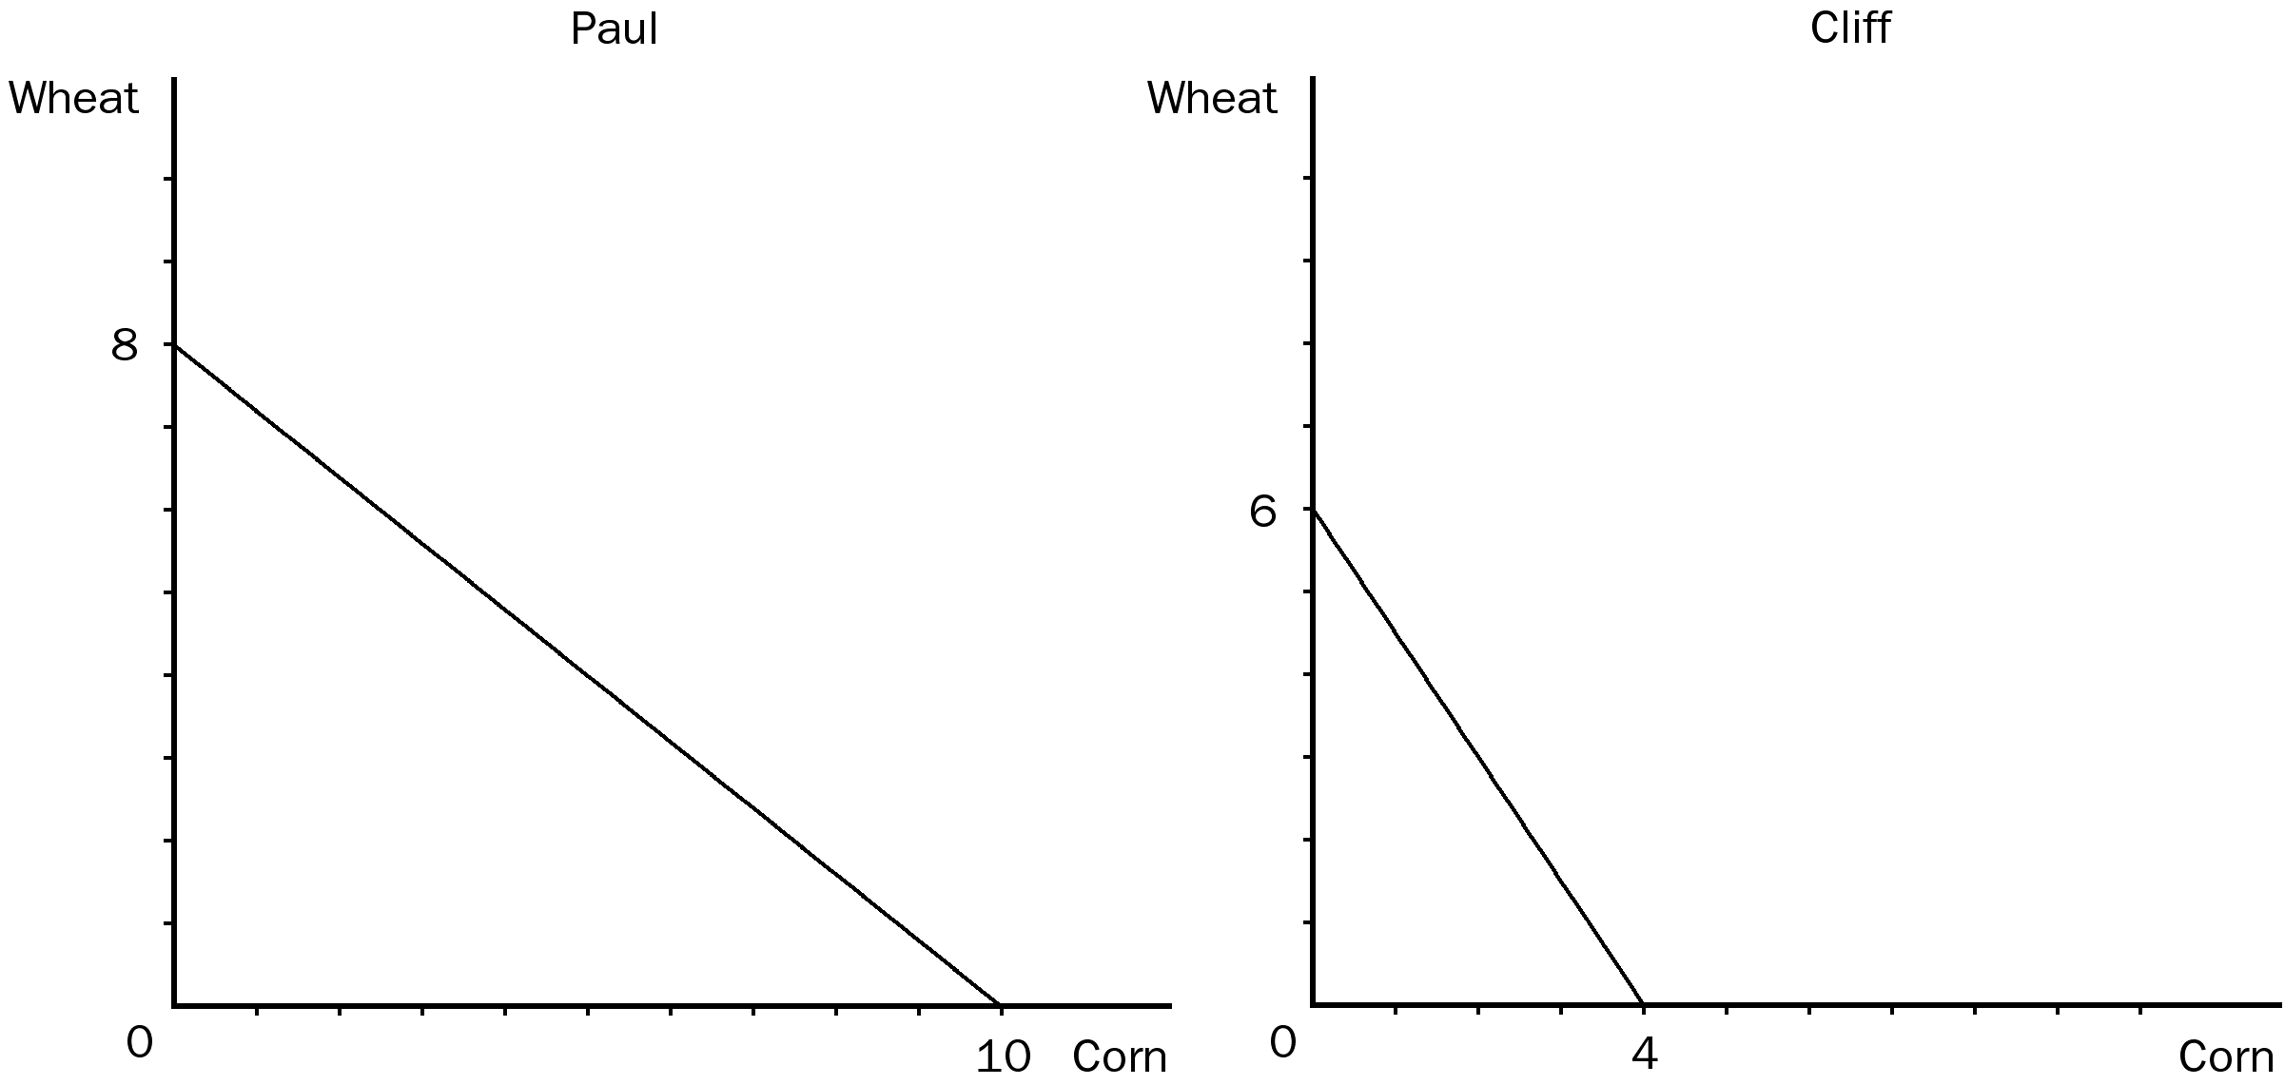

20. According to the graph, if Paul divides his time equally between corn and wheat, he will be able to produce
a. 2 bushels of wheat and 2 bushels of corn.
b. 3 bushels of wheat and 3 bushels of corn.
c. 4 bushels of wheat and 5 bushels of corn.
d. 4 bushels of wheat and 6 bushels of corn.
ANSWER: c. 4 bushels of wheat and 5 bushels of corn.
TYPE: M SECTION: 2 DIFFICULTY: 2
21. According to the graph, the opportunity cost of 1 bushel of wheat for Cliff is
a. 1/3 bushel of corn.
b. 2/3 bushel of corn.
c. 1 bushel of corn.
d. 3/2 bushels of corn.
ANSWER: b. 2/3 bushel of corn.
TYPE: M SECTION: 2 DIFFICULTY: 2
22. According to the graph, assume that both Paul and Cliff divide their time equally between the production of corn and wheat, and they do not trade. If they were the only producers of corn and wheat, then total production of wheat and corn would be
a. 8 bushels of wheat and 7 bushels of corn.
b. 7 bushels of wheat and 6 bushels of corn.
c. 6 bushels of wheat and 8 bushels of corn.
d. 7 bushels of wheat and 7 bushels of corn.
ANSWER: d. 7 bushels of wheat and 7 bushels of corn.
TYPE: M SECTION: 2 DIFFICULTY: 3
23. According to the graph, assume that Cliff and Paul were both producing wheat and corn, and each were dividing their time equally between the two. Then they decide to specialize in the product they have a comparative advantage in. As a result, total production of corn would
a. increase by 1 bushel.
b. increase by 3 bushels.
c. increase by 5 bushels.
d. decrease by 2 bushels.
ANSWER: b. increase by 3 bushels.
TYPE: M SECTION: 2 DIFFICULTY: 3
24. According to the graph, assume that Cliff and Paul were both producing wheat and corn, and each were dividing their time equally between the two. Then they decide to specialize in the product they have a comparative advantage in and trade 3 bushels of wheat for 3 bushels of corn. Cliff would now be able to consume.
a. 4 bushels of wheat and 3 bushels of corn.
b. 3 bushels of wheat and 4 bushels of corn.
c. 3 bushels of wheat and 3 bushels of corn.
d. 2 bushels of wheat and 3 bushels of corn.
ANSWER: c. 3 bushels of wheat and 3 bushels of corn.
TYPE: M SECTION: 2 DIFFICULTY: 3
25. According to the graph, which of the following is true for Cliff and Paul?
a. Paul has an absolute advantage in both wheat and corn.
b. Paul has an absolute advantage in wheat and Cliff has an absolute advantage in corn.
c. Cliff has an absolute advantage in wheat and Paul has an absolute advantage in corn.
d. Cliff has an absolute advantage in both wheat and corn.
ANSWER: a. Paul has an absolute advantage in both wheat and corn.
TYPE: M SECTION: 2 DIFFICULTY: 2
26. According to the graph, which of the following is true for Cliff and Paul?
a. Paul has a comparative advantage in both wheat and corn.
b. Paul has a comparative advantage in wheat and Cliff has a comparative advantage in corn.
c. Cliff has a comparative advantage in wheat and Paul has a comparative advantage in corn.
d. Cliff has a comparative advantage in both wheat and corn.
ANSWER: c. Cliff has a comparative advantage in wheat and Paul has a comparative advantage in corn.
TYPE: M SECTION: 2 DIFFICULTY: 3

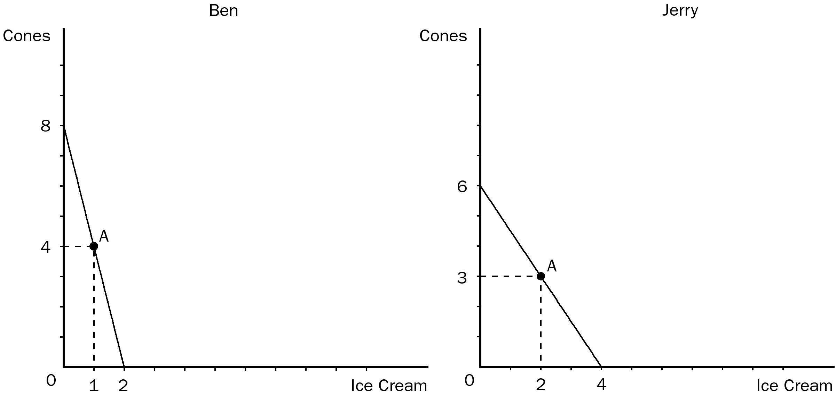

27. According to the graphs, for Ben, the opportunity cost of 1 pound of ice cream is
a. 4 pounds of cones.
b. 1/2 pound of cones.
c. 2 pounds of cones.
d. 1/4 pound of cones.
ANSWER: a. 4 pounds of cones.
TYPE: M SECTION: 2 DIFFICULTY: 3
28. According to the graphs, for Jerry the opportunity cost of 1 pound of ice cream is
a. 1 pound of cones.
b. 3/2 pounds of cones.
c. 1/3 pounds of cones.
d. 2 pounds of cones.
ANSWER: b. 3/2 pounds of cones.
TYPE: M SECTION: 2 DIFFICULTY: 3
29. According to the graphs, for Ben the opportunity cost of 1 pound of cones is
a. 2 pounds of ice cream.
b. 1/2 pound of ice cream.
c. 4 pounds of ice cream.
d. 1/4 pound of ice cream.
ANSWER: d. 1/4 pound of ice cream.
TYPE: M SECTION: 2 DIFFICULTY: 3
30. According to the graphs, for Jerry the opportunity cost of 1 pound of cones is
a. 2/3 pound of ice cream.
b. 3 pounds of ice cream.
c. 1 pound of ice cream.
d. 2 pounds of ice cream.
ANSWER: a. 2/3 pound of ice cream.
TYPE: M SECTION: 2 DIFFICULTY: 3
31. According to the graphs, Ben has a comparative advantage in
a. cones and Jerry has a comparative advantage in ice cream.
b. ice cream and Jerry has a comparative advantage in cones.
c. neither good and Jerry has a comparative advantage in both goods.
d. both goods and Jerry has a comparative advantage in neither good.
ANSWER: a. cones and Jerry has a comparative advantage in ice cream.
TYPE: M SECTION: 2 DIFFICULTY: 3
32. According to the graphs, Ben has an absolute advantage in
a. ice cream and Jerry has an absolute advantage in cones.
b. cones and Jerry has an absolute advantage in ice cream.
c. neither good and Jerry has an absolute advantage in both goods.
d. both goods and Jerry has an absolute advantage in neither good.
ANSWER: b. cones and Jerry has an absolute advantage in ice cream.
TYPE: M SECTION: 2 DIFFICULTY: 2
33. According to the graphs, Ben has a comparative advantage in
a. ice cream and Jerry has an absolute advantage in both goods.
b. cones and Jerry has an absolute advantage in ice cream.
c. ice cream and Jerry has an absolute advantage in neither good.
d. ice cream and Jerry has an absolute advantage in cones.
ANSWER: b. cones and Jerry has an absolute advantage in ice cream.
TYPE: M SECTION: 2 DIFFICULTY: 2
34. According to the graphs, Ben has an absolute advantage in
a. cones and Jerry has a comparative advantage in ice cream.
b. both goods and Jerry has a comparative advantage in cones.
c. ice cream and Jerry has a comparative advantage in cones
d. neither good and Jerry has a comparative advantage in ice cream.
ANSWER: a. cones and Jerry has a comparative advantage in ice cream.
TYPE: M SECTION: 2 DIFFICULTY: 2
35. Suppose that Ben and Jerry have both decided to produce at point A on their production possibilities frontiers, we know that
a. this is not an efficient combination for either Ben or Jerry.
b. Ben and Jerry are both allocating 1/2 their time to the production of each good.
c. no other production point is as efficient for both Ben and Jerry to produce as point A.
d. both should always attempt to produce an equal number of cones and ice cream.
ANSWER: b. Ben and Jerry are both allocating 1/2 their time to the production of each good.
TYPE: M SECTION: 2 DIFFICULTY: 3
36. Ben and Jerry were currently both producing at point A on their production possibilities frontier and then Ben decided he would be willing to trade 4 pounds of cones to get 2 pounds of ice cream from Jerry. If both decided to specialize in what they had a comparative advantage in and trade, the gains from trade would be
a. 1 pound of cones for Ben and 1 pound of ice cream for Jerry.
b. 1 pound of ice cream for Ben and 1 pound of cones for Jerry.
c. 2 pounds of ice cream for Ben and 2 pounds of cones for Jerry.
d. 2 pounds of ice cream for Ben and 1 pound of cones for Jerry.
ANSWER: b. 1 pound of ice cream for Ben and 1 pound of cones for Jerry.
TYPE: M SECTION: 2 DIFFICULTY: 3
For the following question(s), use the accompanying table.

Labor Hours needed to make one unit of: | Amount produced in 160 hours:

 | Quilts | Dresses | Quilts | Dresses
Helen | 40 | 10 | 4 | 16
Carolyn | 80 | 16 | 2 | 10

37. According to the table, the opportunity cost of 1 quilt for Helen is
a. 2 dresses.
b. 3 dresses.
c. 4 dresses.
d. 5 dresses.
ANSWER: c. 4 dresses.
TYPE: M SECTION: 2 DIFFICULTY: 3
38. According to the table, the opportunity cost of 1 quilt for Carolyn is
a. 5 dresses.
b. 4 dresses.
c. 3 dresses.
d. 2 dresses.
ANSWER: a. 5 dresses.
TYPE: M SECTION: 2 DIFFICULTY: 3
39. According to the table, the opportunity cost of 1 dress for Helen is
a. 1 quilt.
b. 1/2 quilt.
c. 1/4 quilt.
d. 4 quilts.
ANSWER: c. 1/4 quilt.
TYPE: M SECTION: 2 DIFFICULTY: 3
40. According to the table, the opportunity cost of 1 dress for Carolyn is
a. 5 quilts.
b. 1 quilt.
c. 1/5 quilt.
d. 4 quilts.
ANSWER: c. 1/5 quilt.
TYPE: M SECTION: 2 DIFFICULTY: 3
41. According to the table, Helen has a comparative advantage in
a. quilts and Carolyn has an absolute advantage in neither good.
b. dresses and Carolyn has an absolute advantage in quilts.
c. quilts and Carolyn has an absolute advantage in dresses.
d. dresses and Carolyn has an absolute advantage in both goods.
ANSWER: a. quilts and Carolyn has an absolute advantage in neither good.
TYPE: M SECTION: 2 DIFFICULTY: 3
42. According to the table, Helen has an absolute advantage in
a. dresses and Carolyn has a comparative advantage in quilts.
b. both goods and Carolyn has a comparative advantage in dresses.
c. quilts and Carolyn has a comparative advantage in dresses.
d. both goods and Carolyn has a comparative advantage in quilts.
ANSWER: b. both goods and Carolyn has a comparative advantage in dresses.
TYPE: M SECTION: 2 DIFFICULTY: 3
43. According to the table, Helen has an absolute advantage in
a. dresses and Carolyn has an absolute advantage in quilts.
b. quilts and Carolyn has an absolute advantage in dresses.
c. neither good and Carolyn has an absolute advantage in both goods.
d. both goods and Carolyn has an absolute advantage in neither good.
ANSWER: d. both goods and Carolyn has an absolute advantage in neither good.
TYPE: M SECTION: 2 DIFFICULTY: 3
44. According to the table, Helen and Carolyn both could benefit by Helen specializing in
a. dresses and Carolyn specializing in quilts.
b. neither good and Carolyn specializing in both goods.
c. quilts and Carolyn specializing in dresses.
d. both goods and Carolyn specializing in neither good.
ANSWER: c. quilts and Carolyn specializing in dresses.
TYPE: M SECTION: 2 DIFFICULTY: 3
45. According to the table, Helen has a comparative advantage in
a. dresses and Carolyn has a comparative advantage in quilts.
b. quilts and Carolyn has a comparative advantage in dresses.
c. neither good and Carolyn has a comparative advantage in both goods.
d. both goods and Carolyn has a comparative advantage in neither good.
ANSWER: b. quilts and Carolyn has a comparative advantage in dresses.
TYPE: M SECTION: 2 DIFFICULTY: 3
These graphs illustrate the production possibilities available for dancing shoes to Fred and Ginger with 40 hours of labor.

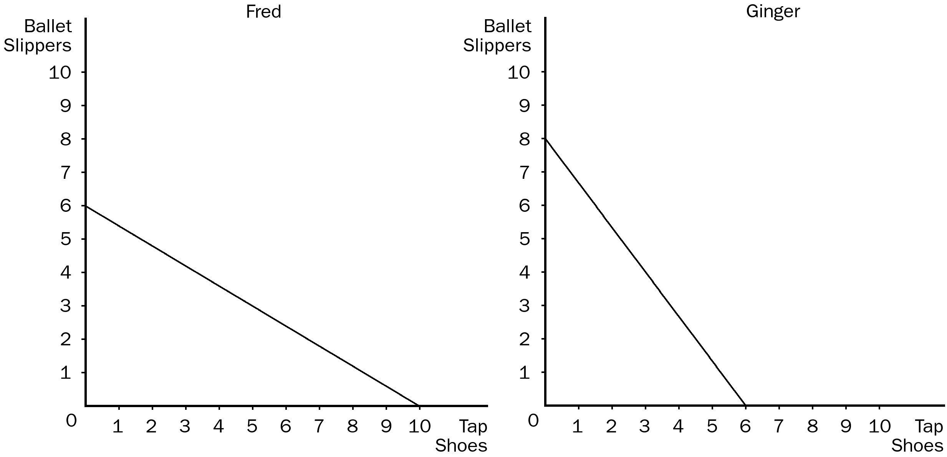

46. According to the graph, the opportunity cost of 1 pair of tap shoes for Fred is
a. 1/3 pair of ballet slippers.
b. 1/5 pair of ballet slippers.
c. 3/5 pair of ballet slippers.
d. 5/3 pairs of ballet slippers.
ANSWER: c. 3/5 pair of ballet slippers.
TYPE: M SECTION: 2 DIFFICULTY: 2
47. According to the graph, the opportunity cost of 1 pair of tap shoes for Ginger is
a. 1/4 pair of ballet slippers.
b. 1/3 pair of ballet slippers.
c. 3/4 pair of ballet slippers.
d. 4/3 pairs of ballet slippers.
ANSWER: d. 4/3 pairs of ballet slippers.
TYPE: M SECTION: 2 DIFFICULTY: 2
48. According to the graph, the opportunity cost of 1 pair of ballet slippers for Ginger is
a. 1/4 pair of tap shoes.
b. 1/3 pair of tap shoes.
c. 3/4 pair of tap shoes.
d. 4/3 pairs of tap shoes.
ANSWER: c. 3/4 pair of tap shoes.
TYPE: M SECTION: 2 DIFFICULTY: 2
49. According to the graph, the opportunity cost of 1 pair of ballet slippers for Fred is
a. 1/3 pair of tap shoes.
b. 1/5 pair of tap shoes.
c. 3/5 pair of tap shoes.
d. 5/3 pairs of tap shoes.
ANSWER: d. 5/3 pairs of tap shoes.
TYPE: M SECTION: 2 DIFFICULTY: 2
50. According to the graph, Ginger has an absolute advantage in
a. ballet slippers and Fred has an absolute advantage in tap shoes.
b. tap shoes and Fred has an absolute advantage in ballet slippers.
c. neither good and Fred has an absolute advantage in both goods.
d. both goods and Fred has an absolute advantage in neither good.
ANSWER: a. ballet slippers and Fred has an absolute advantage in tap shoes.
TYPE: M SECTION: 2 DIFFICULTY: 2
51. According to the graph, Ginger has a comparative advantage in
a. tap shoes and Fred has a comparative advantage in ballet slippers.
b. both goods and Fred has a comparative advantage in neither good.
c. ballet slippers and Fred has a comparative advantage in tap shoes.
d. neither good and Fred has a comparative advantage in both goods.
ANSWER: c. ballet slippers and Fred has a comparative advantage in tap shoes.
TYPE: M SECTION: 2 DIFFICULTY: 3
52. According to the graph, Fred should produce
a. only tap shoes.
b. only ballet slippers.
c. both ballet slippers and tap shoes.
d. neither ballet slippers nor tap shoes.
ANSWER: a. only tap shoes.
TYPE: M SECTION: 2 DIFFICULTY: 2
53. According to the graph, Ginger has an absolute advantage in
a. tap shoes and Fred has a comparative advantage in ballet slippers.
b. both goods and Fred has a comparative advantage in neither good.
c. ballet slippers and Fred has a comparative advantage in tap shoes.
d. neither good and Fred has a comparative advantage in both goods.
ANSWER: c. ballet slippers and Fred has a comparative advantage in tap shoes.
TYPE: M SECTION: 2 DIFFICULTY: 3
54. According to the graph, Ginger should specialize in
a. tap shoes and Fred should specialize in ballet slippers.
b. both goods and Fred should specialize in neither good.
c. ballet slippers and Fred should specialize in tap shoes.
d. neither good and Fred should specialize in both goods.
ANSWER: c. ballet slippers and Fred should specialize in tap shoes.
TYPE: M SECTION: 2 DIFFICULTY: 3
55. According to the graph, if Fred and Ginger devote 1/2 of their time (20 hours) to the production of each good, total production of ballet slippers would be
a. 7 and total production of tap shoes would be 8.
b. 8 and total production of tap shoes would be 8.
c. 9 and total production of tap shoes would be 6.
d. 10 and total production of tap shoes would be 8.
ANSWER: a. 7 and total production of tap shoes would be 8.
TYPE: M SECTION: 2 DIFFICULTY: 2
56. According to the graph, if Fred and Ginger both specialize in the good in which they have a comparative advantage, total production of ballet slippers would be
a. 6 and total production of tap shoes would be 6.
b. 8 and total production of tap shoes would be 6.
c. 8 and total production of tap shoes would be 8.
d. 8 and total production of tap shoes would be 10.
ANSWER: d. 8 and total production of tap shoes would be 10.
TYPE: M SECTION: 2 DIFFICULTY: 2
57. According to the graph, if Fred and Ginger both specialize in the good in which they have a comparative advantage, total consumption of ballet slippers will be
a. 4 and total consumption of tap shoes will be 6.
b. 6 and total consumption of tap shoes will be 6.
c. 8 and total consumption of tap shoes will be 8.
d. 8 and total consumption of tap shoes will be 10.
ANSWER: d. 8 and total consumption of tap shoes will be 10.
TYPE: M SECTION: 2 DIFFICULTY: 2
58. Suppose a gardener produces both green beans and corn in her garden. If she must give up 13 bushels of corn to get 5 bushels of green beans, then the opportunity cost of 1 bushel of green beans is
a. 0.38 bushel of corn.
b. 2.6 bushels of corn.
c. 8 bushels of corn.
d. 18 bushels of corn.
ANSWER: b. 2.6 bushels of corn.
TYPE: M SECTION: 2 DIFFICULTY: 2
59. Suppose a gardener produces both green beans and corn in her garden. If the opportunity cost of one bushel of corn is 3/5 bushel of green beans, then the opportunity cost of 1 bushel of green beans is
a. 5/3 bushels of corn.
b. 2/5 bushel of corn.
c. 5/2 bushels of corn.
d. 8/5 bushels of corn.
ANSWER: a. 5/3 bushels of corn.
TYPE: M SECTION: 2 DIFFICULTY: 2
60. Using all available resources, if a farmer can produce either 85 cantaloupes or 70 watermelons, then the opportunity cost of 1 cantaloupe to the farmer would be
a. .82 watermelons.
b. 1.21 watermelons.
c. 15 watermelons.
d. There is not enough information given to answer this question.
ANSWER: a. .82 watermelons.
TYPE: M SECTION: 2 DIFFICULTY: 2
61. Currently, a farmer can either grow 40 bushels of wheat or 120 bushels of corn per acre. If he were able to trade 80 bushels of corn for 30 bushels of wheat he would be
a. worse off because his opportunity cost of wheat would increase from 2.6 bushels of corn to 3 bushels of corn.
b. better off because his opportunity cost of wheat would fall from 80 bushels to 50 bushels.
c. better off because his opportunity cost of wheat would fall from 3 bushels of corn to 2.6 bushels.
d. There is not enough information to answer this question.
ANSWER: c. better off because his opportunity cost of wheat would fall from 3 bushels of corn to 2.6 bushels.
TYPE: M SECTION: 2 DIFFICULTY: 3
62. If Shawn can produce donuts at a lower opportunity cost than Sue, then
a. Shawn has a comparative advantage in the production of donuts.
b. Sue has a comparative advantage in the production of donuts.
c. Shawn should be retrained and produce a different product.
d. it is obvious that Shawn is capable of producing more donuts than Sue.
ANSWER: a. Shawn has a comparative advantage in the production of donuts.
TYPE: M SECTION: 2 DIFFICULTY: 2

Labor Hours Needed to Make One Unit of: | Amount Produced in 24 Hours:

 | Baskets | Birdhouses | Baskets | Birdhouses
Montana | 6 | 2 | 4 | 12
Missouri | 3 | 4 | 8 | 6

63. Given the information in the table, the opportunity cost of 1 basket for Montana is
a. 1/3 birdhouse.
b. 1 birdhouse.
c. 3 birdhouses.
d. 4 birdhouses.
ANSWER: c. 3 birdhouses.
TYPE: M SECTION: 2 DIFFICULTY: 3
64. Given the information in the table, the opportunity cost of 1 basket for Missouri is
a. 1/4 birdhouse.
b. 3/4 birdhouse.
c. 1 birdhouse.
d. 4/3 birdhouses.
ANSWER: b. 3/4 birdhouse.
TYPE: M SECTION: 2 DIFFICULTY: 3
65. Given the information in the table, the opportunity cost of 1 birdhouse for Montana is
a. 1/3 basket.
b. 1 basket.
c. 4/3 baskets.
d. 3 baskets.
ANSWER: a. 1/3 basket.
TYPE: M SECTION: 2 DIFFICULTY: 3
66. Given the information in the table, the opportunity cost of 1 birdhouse for Montana is
a. 1/3 basket.
b. 1 basket.
c. 4/3 baskets.
d. 3 baskets.
ANSWER: c. 4/3 baskets.
TYPE: M SECTION: 2 DIFFICULTY: 3
67. Given the information in the table, Montana has an absolute advantage in
a. birdhouses and Missouri has an absolute advantage in baskets.
b. baskets and Missouri has an absolute advantage in birdhouses.
c. neither good and Missouri has an absolute advantage in both goods.
d. both goods and Missouri has an absolute advantage in neither good.
ANSWER: a. birdhouses and Missouri has an absolute advantage in baskets.
TYPE: M SECTION: 2 DIFFICULTY: 3
68. Given the information in the table, Montana has a comparative advantage in
a. baskets and Missouri has a comparative advantage in birdhouses.
b. birdhouses and Missouri has a comparative advantage in baskets.
c. neither good and Missouri has a comparative advantage in both goods.
d. both goods and Missouri has a comparative advantage in neither good.
ANSWER: b. birdhouses and Missouri has a comparative advantage in baskets.
TYPE: M SECTION: 2 DIFFICULTY: 3
69. Given the information in the table, if Montana and Missouri trade based on the principle of comparative advantage, Montana will export
a. baskets and Missouri will export birdhouses.
b. birdhouses and Missouri will export baskets.
c. neither good and Missouri will export both goods.
d. both goods and Missouri will export neither good.
ANSWER: b. birdhouses and Missouri will export baskets.
TYPE: M SECTION: 2 DIFFICULTY: 3
70. Given the information in the table, if Montana and Missouri trade based on the principle of comparative advantage, Montana will export
a. all individuals in both states will gain.
b. no one in either state will gain.
c. some individuals within each state will be made worse off.
d. one state will be better off and the other state will be worse off.
ANSWER: c. some individuals within each state will be made worse off.
TYPE: M SECTION: 2 DIFFICULTY: 2
71. Comparative advantage is based on
a. capital costs.
b. labor costs.
c. dollar price.
d. opportunity costs.
ANSWER: d. opportunity costs.
TYPE: M SECTION: 2 DIFFICULTY: 1
72. Trade is based on
a. absolute advantage.
b. comparative advantage.
c. production costs.
d. relative dollar prices.
ANSWER: b. comparative advantage.
TYPE: M SECTION: 2 DIFFICULTY: 1
73. For two people who are planning to trade, it is impossible to
a. have a comparative advantage in both goods.
b. have an absolute advantage in both goods.
c. specialize in the production of one good.
d. trade so that both people will be better off.
ANSWER: a. have a comparative advantage in both goods.
TYPE: M SECTION: 2 DIFFICULTY: 2
74. For two people who are planning to trade two different goods, each will have a comparative advantage in a different good unless
a. they have exactly the same opportunity cost.
b. they have agreed in advance on who will produce what and how much each will produce.
c. the terms of trade are such that neither can gain from trade.
d. one person has an absolute advantage in both products.
ANSWER: a. they have exactly the same opportunity cost.
TYPE: M SECTION: 2 DIFFICULTY: 2
75. Suppose that Korea produces shoes and soccer balls. For Korea,
a. it should specialize in the product in which it has an absolute advantage.
b. it would be impossible to have an absolute advantage in both goods.
c. it would be difficult to benefit from trade since Korea is efficient in the production of both goods.
d. the opportunity cost of shoes will be the inverse of its opportunity cost of soccer balls.
ANSWER: d. the opportunity cost of shoes will be the inverse of its opportunity cost of soccer balls.
TYPE: M SECTION: 2 DIFFICULTY: 2
76. Comparative advantage reflects
a. productivity.
b. relative opportunity cost.
c. efficiency.
d. terms of trade advantage.
ANSWER: b. relative opportunity cost.
TYPE: M SECTION: 2 DIFFICULTY: 2
77. Which of the following is NOT true concerning comparative advantage?
a. The comparative advantage is determined by which person can produce a good using fewer inputs.
b. The principle of comparative advantage applies to countries as well as people.
c. Economists use the principle of comparative advantage to advocate free trade.
d. Gains from trade are based on the principle of comparative advantage.
ANSWER: a. The comparative advantage is determined by which person can produce a good using fewer inputs.
TYPE: M SECTION: 2 DIFFICULTY: 2
78. Assume that Greece has a comparative advantage in fish and Germany has a comparative advantage in cars. If these two countries specialize and trade according to their comparative advantage
a. all individuals in both countries will benefit.
b. Greece will specialize in and export cars.
c. Germany will produce more cars than in the absence of trade.
d. Germany will produce more fish than in the absence of trade.
ANSWER: c. Germany will produce more cars than in the absence of trade.
TYPE: M SECTION: 3 DIFFICULTY: 2
79. Assume that Greece has a comparative advantage in fish and Germany has a comparative advantage in cars. If these two countries specialize and trade according to their comparative advantage, which of the following would NOT be true?
a. Greece will specialize in and export fish.
b. Some individuals in each country will be hurt.
c. More of each good can be consumed in both countries.
d. Greece will benefit from trade more than Germany.
ANSWER: d. Greece will benefit from trade more than Germany.
TYPE: M SECTION: 3 DIFFICULTY: 2
80. Belarus has a comparative advantage in the production of linen, but Russia has an absolute advantage in the production of linen. If these two countries decide to trade
a. Belarus should export linen to Russia.
b. Russia should export linen to Belarus.
c. For these two countries, trading linen would be a “stand-off” so they should trade another product.
d. Without additional information about Russia, this question cannot be answered.
ANSWER: a. Belarus should export linen to Russia.
TYPE: M SECTION: 3 DIFFICULTY: 2
81. The country that has a comparative advantage in a product
a. should import that product.
b. should export that product.
c. would be better off keeping the product for domestic use since it is relatively inexpensive to produce.
d. None of the above are correct.
ANSWER: b. should export that product.
TYPE: M SECTION: 3 DIFFICULTY: 1
82. The producer that requires a smaller quantity of inputs to produce a good
a. should import that good.
b. has a comparative advantage in the production of that good.
c. has an absolute advantage in the production of that good.
d. Both a and b are correct.
ANSWER: c. has an absolute advantage in the production of that good.
TYPE: M SECTION: 3 DIFFICULTY: 2
83. The producer that can produce a product with lower opportunity cost
a. has a comparative advantage in the production of that good.
b. has an absolute advantage in the production of that good.
c. should import that product.
d. Both b and c are correct.
ANSWER: a. has a comparative advantage in the production of that good.
TYPE: M SECTION: 3 DIFFICULTY: 2
84. The opportunity cost of an item is
a. the number of hours needed to earn money to buy it.
b. what you give up to get that item.
c. always less than the dollar value of the item.
d. always equal to the dollar value of the item.
ANSWER: b. what you give up to get that item.
TYPE: M SECTION: 3 DIFFICULTY: 1
85. The term which means whatever must be given up to obtain an item is
a. efficiency.
b. externality.
c. opportunity cost.
d. market failure.
ANSWER: c. opportunity cost.
TYPE: M SECTION: 3 DIFFICULTY: 1
86. Absolute advantage is found by
a. comparing opportunity costs.
b. calculating the dollar cost of production.
c. comparing the productivity of one nation to that of another.
d. first determining which country has a comparative advantage.
ANSWER: c. comparing the productivity of one nation to that of another.
TYPE: M SECTION: 2 DIFFICULTY: 2
87. Trade
a. allows a person to consume at a point outside his production possibilities frontier.
b. limits a person’s ability to produce goods and services on her own.
c. must benefit both traders equally.
d. is based on absolute advantage.
ANSWER: a. allows a person to consume at a point outside his production possibilities frontier.
TYPE: M SECTION: 2 DIFFICULTY: 1
88. Trade can benefit society as a whole because it allows for each of the following EXCEPT
a. a more efficient use of resources.
b. goods to be obtained at a lower opportunity cost.
c. people to specialize in activities in which they have a comparative advantage.
d. some countries to gain political control over trading partners.
ANSWER: d. some countries to gain political control over trading partners.
TYPE: M SECTION: 2 DIFFICULTY: 2
89. When countries specialize according to their comparative advantage,
a. it is possible to increase world output of all goods.
b. it is possible to increase world output of some goods only by reducing the output of others.
c. one country is likely to gain from trade while others lose.
d. all countries will lose from trade.
ANSWER: a. it is possible to increase world output of all goods.
TYPE: M SECTION: 2 DIFFICULTY: 2
90. Which of the following would NOT occur if each person specializes in the good for which they have a comparative advantage?
a. Each person’s production possibilities frontier will shift outward.
b. Total production in the economy will increase.
c. Everyone can be better off with specialization and trade.
d. The size of the economic pie will increase.
ANSWER: a. Each person’s production possibilities frontier will shift outward.
TYPE: M SECTION: 2 DIFFICULTY: 2
91. Total output in an economy increases when each person specializes because
a. there is much less competition for the same resources.
b. each person spends more time producing that product for which they have a comparative advantage.
c. a wider variety of products can be produced with specialization.
d. more people will be producing products than before.
ANSWER: b. each person spends more time producing that product for which they have a comparative advantage.
TYPE: M SECTION: 2 DIFFICULTY: 2
92. Mike and Sandy are two woodworkers who both make tables and chairs. In one month, Mike can make 4 tables or 20 chairs, where Sandy can make 6 tables or 18 chairs. Given this, we know that
a. Mike has an absolute advantage in chairs.
b. Mike has a comparative advantage in tables.
c. Sandy has an absolute advantage in chairs.
d. Sandy has a comparative advantage in chairs.
ANSWER: a. Mike has an absolute advantage in chairs.
TYPE: M SECTION: 2 DIFFICULTY: 3
93. Mike and Sandy are two woodworkers who both make tables and chairs. In one month, Mike can make 4 tables or 20 chairs, where Sandy can make 6 tables or 18 chairs. Given this, we know that
a. Mike has a comparative advantage in tables.
b. Sandy has an absolute advantage in chairs.
c. Mike has an absolute advantage in tables.
d. Sandy has a comparative advantage in tables.
ANSWER: d. Sandy has a comparative advantage in tables.
TYPE: M SECTION: 2 DIFFICULTY: 3
94. Mike and Sandy are two woodworkers who both make tables and chairs. In one month, Mike can make 4 tables or 20 chairs, where Sandy can make 6 tables or 18 chairs. Given this, we know that the opportunity cost of 1 chair for
a. Mike is 1/5 table and 1/3 table for Sandy.
b. Mike is 5 tables and 3 tables for Sandy.
c. Mike is 1/3 table and 1/5 table for Sandy.
d. Mike is 3 tables and 5 tables for Sandy.
ANSWER: a. Mike is 1/5 table and 1/3 table for Sandy.
TYPE: M SECTION: 2 DIFFICULTY: 3
95. Mike and Sandy are two woodworkers who both make tables and chairs. In one month, Mike can make 4 tables or 20 chairs, where Sandy can make 6 tables or 18 chairs. Given this, we know that the opportunity cost of 1 table for
a. Mike is 1/5 chair and 1/3 chair for Sandy.
b. Mike is 5 chairs and 3 chairs for Sandy.
c. Mike is 1/3 chair and 1/5 chair for Sandy.
d. Mike is 3 chairs and 5 chairs for Sandy.
ANSWER: b. Mike is 5 chairs and 3 chairs for Sandy.
TYPE: M SECTION: 2 DIFFICULTY: 3

These figures illustrate the production possibilities available to Barney and Betty with 8 hours of labor in their bakery.

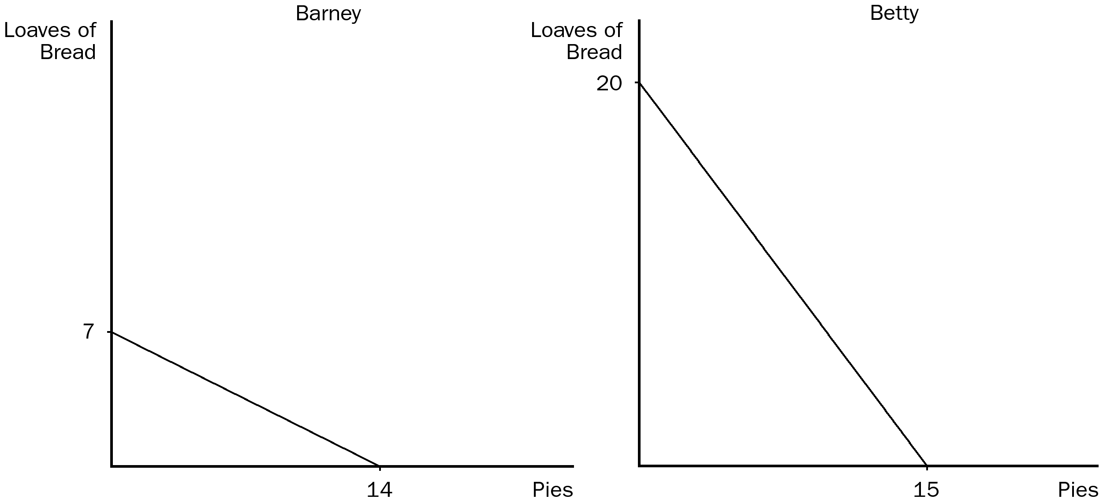

96. According to the graphs shown, the opportunity cost of 1 loaf of bread for Barney is
a. 1/4 pie.
b. 1/2 pie.
c. 1 pie.
d. 2 pies.
ANSWER: d. 2 pies.
TYPE: M SECTION: 2 DIFFICULTY: 3
97. According to the graphs shown, the opportunity cost of 1 pie for Betty is
a. 1/4 loaf of bread.
b. 3/4 loaf of bread.
c. 1 loaf of bread.
d. 4/3 loaves of bread.
ANSWER: d. 4/3 loaves of bread.
TYPE: M SECTION: 2 DIFFICULTY: 2
98. According to the graphs shown, Barney has an absolute advantage in
a. both goods and Betty has an absolute advantage in neither good.
b. loaves of bread and Betty has an absolute advantage in pies.
c. neither good and Betty has an absolute advantage in both goods.
d. pies and Betty has an absolute advantage in loaves of bread.
ANSWER: c. neither good and Betty has an absolute advantage in both goods.
TYPE: M SECTION: 2 DIFFICULTY: 3
99. According to the graphs shown, Barney has a comparative advantage in
a. both goods and Betty has a comparative advantage in neither good.
b. loaves of bread and Betty has a comparative advantage in pies.
c. neither good and Betty has a comparative advantage in both goods.
d. pies and Betty has a comparative advantage in loaves of bread.
ANSWER: d. pies and Betty has a comparative advantage in loaves of bread.
TYPE: M SECTION: 2 DIFFICULTY: 3
100. According to the graphs shown, if Barney and Betty both specialize in the good in which they have a comparative advantage, total production of bread will be
a. 7 and total production of pies will be 15.
b. 20 and total production of pies will be 14.
c. 27 and total production of pies will be 29.
d. 40 and total production of pies will be 22.
ANSWER: b. 20 and total production of pies will be 14.
TYPE: M SECTION: 2 DIFFICULTY: 3

Hours needed to make one unit of: | Amount produced in 2400 hours:

 | Cars | Airplanes | Cars | Airplanes
U.S. | 40 | 160 | 60 | 15
Japan | 50 | 150 | 48 | 16

101. According to the tables shown, the opportunity cost of 1 car for Japan is
a. 4 airplanes.
b. 3 airplanes.
c. 1/3 airplane.
d. 1/4 airplane.
ANSWER: c. 1/3 airplane.
TYPE: M SECTION: 3 DIFFICULTY: 2
102. According to the tables shown, the opportunity cost of 1 airplane for Japan is
a. 4 cars.
b. 3 cars.
c. 1/3 car.
d. 1/4 car.
ANSWER: b. 3 cars.
TYPE: M SECTION: 3 DIFFICULTY: 2
103. According to the tables shown, the opportunity cost of 1 car for the United States is
a. 4 airplanes.
b. 3 airplanes.
c. 1/3 airplane.
d. 1/4 airplane.
ANSWER: d. 1/4 airplane.
TYPE: M SECTION: 3 DIFFICULTY: 2
104. According to the tables shown, the opportunity cost of 1 airplane for the United States is
a. 4 cars.
b. 3 cars.
c. 1/3 car.
d. 1/4 car.
ANSWER: a. 4 cars.
TYPE: M SECTION: 3 DIFFICULTY: 2
105. According to the table shown, Japan has a comparative advantage in
a. airplanes and the United States has an absolute advantage in cars.
b. cars and the United States has an absolute advantage in airplanes.
c. cars and the United States has an absolute advantage in neither good.
d. airplanes and the United States has an absolute advantage in both goods.
ANSWER: a. airplanes and the United States has an absolute advantage in cars.
TYPE: M SECTION: 3 DIFFICULTY: 2
106. According to the table shown, Japan has an absolute advantage in
a. both goods and the United States has a comparative advantage in cars.
b. both goods and the United States has a comparative advantage in neither good.
c. cars and the United States has a comparative advantage in airplanes.
d. airplanes and the United States has a comparative advantage in cars.
ANSWER: d. airplanes and the United States has a comparative advantage in cars.
TYPE: M SECTION: 3 DIFFICULTY: 2
107. According to the table shown, the United States has an absolute advantage in
a. airplanes and Japan has an absolute advantage in cars.
b. neither good and Japan has an absolute advantage in both goods.
c. cars and Japan has an absolute advantage in airplanes.
d. neither good and Japan has an absolute advantage in cars.
ANSWER: c. cars and Japan has an absolute advantage in airplanes.
TYPE: M SECTION: 3 DIFFICULTY: 2
108. According to the table shown, the United States has a comparative advantage in
a. airplanes and Japan has a comparative advantage in airplanes.
b. cars and Japan has a comparative advantage in airplanes.
c. airplanes and Japan has a comparative advantage in cars.
d. neither good and Japan has a comparative advantage in cars.
ANSWER: b. cars and Japan has a comparative advantage in airplanes.
TYPE: M SECTION: 3 DIFFICULTY: 2
109. According to the table shown, the United States and Japan could benefit by the United States specializing in
a. airplanes and Japan specializing in airplanes.
b. cars and Japan specializing in airplanes.
c. airplanes and Japan specializing in cars.
d. neither good and Japan specializing in cars.
ANSWER: b. cars and Japan specializing in airplanes.
TYPE: M SECTION: 3 DIFFICULTY:
110. According to the table shown, if the United States and Japan trade based on the principle of comparative advantage, the United States will export what product to Japan?
a. cars
b. both airplanes and cars
c. airplanes
d. The United States should buy both products from Japan.
ANSWER: a. cars
TYPE: M SECTION: 3 DIFFICULTY: 2
111. According to the table shown, if the United States and Japan trade based on the principle of comparative advantage, Japan will export what product to the United States?
a. cars
b. both airplanes and cars
c. airplanes
d. Japan should buy both products from the United States.
ANSWER: c. airplanes
TYPE: M SECTION: 3 DIFFICULTY: 2
112. According to the table shown, if the United States and Japan trade based on the principle of comparative advantage, the United States will export
a. cars and Japan will export airplanes.
b. airplanes and Japan will export cars.
c. cars and Japan will export cars.
d. airplanes and Japan will export airplanes.
ANSWER: a. cars and Japan will export airplanes.
TYPE: M SECTION: 3 DIFFICULTY: 2
113. According to the table shown, if Japan and the United States trade based on the principle of comparative advantage,
a. all individuals in both countries will gain.
b. car producers in Japan and airplane producers in the United States will gain.
c. some individuals within each society will be made worse off.
d. one country will be better off and the other country will be worse off.
ANSWER: c. some individuals within each society will be made worse off.
TYPE: M SECTION: 3 DIFFICULTY: 2
114. According to the table shown, if Japan and the United States trade based on the principle of comparative advantage,
a. all individuals in both countries will gain.
b. both countries can have more airplanes and cars.
c. Japan will specialize in cars and the United States will specialize in airplanes.
d. both countries will consume on their own production possibilities frontier.
ANSWER: b. both countries can have more airplanes and cars.
TYPE: M SECTION: 3 DIFFICULTY: 2
115. A good that is produced abroad and sold domestically is called
a. a quota.
b. a tariff.
c. an import.
d. an export.
ANSWER: c. an import.
TYPE: M SECTION: 3 DIFFICULTY: 1
116. Imports are
a. people who work in foreign countries.
b. an example of an economic model.
c. whatever is given up to obtain some item.
d. goods produced abroad and sold domestically.
ANSWER: d. goods produced abroad and sold domestically.
TYPE: M SECTION: 3 DIFFICULTY: 1
117. Exports are
a. a limit placed on the quantity of goods brought into a country.
b. goods produced abroad and sold domestically.
c. a country’s ability to produce a good.
d. goods produced domestically and sold abroad.
ANSWER: d. goods produced domestically and sold abroad.
TYPE: M SECTION: 3 DIFFICULTY: 1
118. A tax placed on imported goods is called
a. a quota.
b. a tariff.
c. an import.
d. an export.
ANSWER: b. a tariff.
TYPE: M SECTION: 3 DIFFICULTY: 1
119. Tariffs are
a. taxes placed on imported products.
b. quantity limits placed on imported products.
c. goods produced domestically and sold abroad.
d. the same as a quota.
ANSWER: a. taxes placed on imported products.
TYPE: M SECTION: 3 DIFFICULTY: 1
120. While in office, President Clinton announced stiff import tariffs on
a. beef from Argentina.
b. lamb from Australia.
c. shoes from Korea.
d. vodka from Russia.
ANSWER: b. lamb from Australia.
TYPE: M SECTION: 3 DIFFICULTY: 1
121. Adam Smith
a. wrote An Inquiry into the Nature and Causes of the Wealth of Nations.
b. opposed free trade.
c. wrote the General Theory of Economics.
d. All of the above are correct.
ANSWER: a. wrote An Inquiry into the Nature and Causes of the Wealth of Nations.
TYPE: M SECTION: 3 DIFFICULTY: 1
122. According to Adam Smith, a person should never attempt to make at home
a. what it will cost him more to make than to buy.
b. everything one person needs to live.
c. what one doesn’t know how to make.
d. any necessity of life.
ANSWER: a. what it will cost him more to make than to buy.
TYPE: M SECTION: 3 DIFFICULTY: 2
123. The principle of comparative advantage was developed by
a. Harry Truman.
b. David Ricardo.
c. John Maynard Keynes.
d. Adam Smith.
ANSWER: b. David Ricardo.
TYPE: M SECTION: 3 DIFFICULTY: 1
124. David Ricardo
a. wrote books opposing the ideas of Adam Smith.
b. was the founder of modern economics.
c. argued in favor of Britain following a free-trade policy.
d. wrote An Inquiry into the Nature and Causes of the Wealth of Nations in 1776.
ANSWER: c. argued in favor of Britain following a free-trade policy.
TYPE: M SECTION: 3 DIFFICULTY: 1
125. David Ricardo, a millionaire stockbroker and economist
a. opposed the Corn Laws as a member of Parliament.
b. disputed Adam Smith’s theory of specialization and trade in the early 1800s.
c. developed the principle of comparative advantage in 1817, which has been largely disproved by modern economists.
d. was an early supporter of trade restrictions.
ANSWER: a. opposed the Corn Laws as a member of Parliament.
TYPE: M SECTION: 3 DIFFICULTY: 1
126. David Ricardo was the author of
a. Inquiry into the Nature and Causes of the Wealth of Nations.
b. Principles of Political Economy and Taxation.
c. The General Theory of Prices and Employment.
d. Why Nations Trade.
ANSWER: b. Principles of Political Economy and Taxation.
TYPE: M SECTION: 3 DIFFICULTY: 1
127. Economists generally support
a. trade restrictions.
b. government management of trade.
c. export subsidies.
d. free international trade.
ANSWER: d. free international trade.
TYPE: M SECTION: 3 DIFFICULTY: 1
128. If Karl Malone (1997 NBA MVP) is a better basketball player and truck driver than Gregory Mankiw (the author of your economics text), which of the following is true?
a. Karl Malone will have a lower opportunity cost of playing basketball and truck driving than will Gregory Mankiw.
b. Karl Malone would be better off playing basketball and driving his own truck.
c. Karl Malone will probably have a comparative advantage in both goods.
d. Karl Malone and Gregory Mankiw may benefit from trade.
ANSWER: d. Karl Malone and Gregory Mankiw may benefit from trade.
TYPE: M SECTION: 3 DIFFICULTY: 2
129. The United States could benefit by
a. restricting imports and promoting exports.
b. promoting imports and restricting exports.
c. restricting both imports and exports.
d. not restricting trade.
ANSWER: d. not restricting trade.
TYPE: M SECTION: 3 DIFFICULTY: 2
130. The gains from trade are
a. higher from trade between a rich nation and a poor nation.
b. based on different wage rates between nations.
c. a result of more efficient resource allocation.
d. based on the principle of absolute advantage.
ANSWER: c. a result of more efficient resource allocation.
TYPE: M SECTION: 3 DIFFICULTY:2
131. Trade can make everybody better off because it
a. increases cooperation among nations.
b. allows people to specialize according to comparative advantage.
c. requires some workers in an economy to be retrained.
d. reduces competition among domestic companies.
ANSWER: b. allows people to specialize according to comparative advantage.
TYPE: M SECTION: 3 DIFFICULTY:2

Use the accompanying table to answer the following questions:

Labor hours needed to make one unit of | Amount produced in 40 hours

 | Cheese | Bread | Cheese | Bread
England | 1 | 2 | 40 | 20
Spain | 2 | 8 | 20 | 5

132. According to the table, the opportunity cost of 1 unit of cheese in England is
a. 4 breads.
b. 2 breads.
c. 1/2 bread.
d. 1/4 bread.
ANSWER: c. 1/2 bread.
TYPE: M SECTION: 3 DIFFICULTY: 3
133. According to the table, the opportunity cost of 1 unit of bread in England is
a. 4 cheeses.
b. 2 cheeses.
c. 1 cheese.
d. 1/2 cheese.
ANSWER: b. 2 cheeses.
TYPE: M SECTION: 3 DIFFICULTY: 3
134. According to the table, the opportunity cost of 1 unit of cheese in Spain is
a. 2 breads.
b. 1 bread.
c. 1/2 bread.
d. 1/4 bread.
ANSWER: d. 1/4 bread.
TYPE: M SECTION: 3 DIFFICULTY: 3
135. According to the table, the opportunity cost of 1 unit of bread in Spain is
a. 4 cheeses.
b. 2 cheeses.
c. 1 cheese.
d. 1/4 cheese.
ANSWER: a. 4 cheeses.
TYPE: M SECTION: 3 DIFFICULTY: 3
136. According to the table, England has a comparative advantage in
a. bread and Spain has a comparative advantage in cheese.
b. cheese and Spain has a comparative advantage in bread.
c. both goods and Spain has a comparative advantage in neither good.
d. neither good and Spain has a comparative advantage in both goods.
ANSWER: a. bread and Spain has a comparative advantage in cheese.
TYPE: M SECTION: 3
137. According to the table, England has an absolute advantage in
a. bread and Spain has an absolute advantage in cheese.
b. cheese and Spain has an absolute advantage in bread.
c. neither good and Spain has an absolute advantage in both goods.
d. both goods and Spain has an absolute advantage in neither good.
ANSWER: d. both goods and Spain has an absolute advantage in neither good.
TYPE: M SECTION: 3 DIFFICULTY: 3
138. According to the table, England has a comparative advantage in
a. bread and Spain has an absolute advantage in cheese.
b. bread and Spain has an absolute advantage in neither good.
c. cheese and Spain has an absolute advantage in both goods.
d. both goods and Spain has an absolute advantage in cheese.
ANSWER: b. bread and Spain has an absolute advantage in neither good.
TYPE: M SECTION: 3 DIFFICULTY: 3
139. According to the table, England has an absolute advantage in
a. bread and Spain has a comparative advantage in cheese.
b. bread and Spain has a comparative advantage in neither good.
c. cheese and Spain has a comparative advantage in both goods.
d. both goods and Spain has a comparative advantage in cheese.
ANSWER: d. both goods and Spain has a comparative advantage in cheese.
TYPE: M SECTION: 3 DIFFICULTY: 3
140. According to the table, England and Spain could benefit by England specializing in
a. bread and Spain specializing in cheese.
b. cheese and Spain specializing in bread.
c. both goods and Spain specializing in neither good.
d. neither good and Spain specializing in both goods.
ANSWER: a. bread and Spain specializing in cheese.
TYPE: M SECTION: 3 DIFFICULTY: 3
141. According to the table, if England and Spain trade based on the principle of comparative advantage, England will export which product to Spain?
a. cheese
b. bread
c. both cheese and bread
d. England cannot benefit from trade with Spain.
ANSWER: b. bread
TYPE: M SECTION: 3 DIFFICULTY: 2
142. According to the table, if England and Spain trade based on the principle of comparative advantage, Spain will export which product to England?
a. bread
b. both bread and cheese
c. cheese
d. Spain cannot benefit from trade with Spain.
ANSWER: c. cheese
TYPE: M SECTION: 3 DIFFICULTY: 2
143. According to the table, if England and Spain trade based on the principle of comparative advantage, England will export
a. bread and Spain will export cheese.
b. bread and Spain will export bread.
c. cheese and Spain will export cheese.
d. cheese and Spain will export bread.
ANSWER: a. bread and Spain will export cheese.
TYPE: M SECTION: 3 DIFFICULTY: 3
144. According to the table, if England and Spain trade based on the principle of comparative advantage, England will import
a. bread and Spain will import cheese.
b. bread and Spain will import bread.
c. cheese and Spain will import bread.
d. cheese and Spain will import cheese.
ANSWER: c. cheese and Spain will import bread.
TYPE: M SECTION: 3 DIFFICULTY: 3
145. According to the table, if England and Spain specialize and trade according to their respective comparative advantage,
a. all individuals in both countries will benefit.
b. Spain will specialize in and export bread.
c. England will produce more bread than in the absence of trade.
d. England will produce more cheese than in the absence of trade.
ANSWER: c. England will produce more bread than in the absence of trade.
TYPE: M SECTION: 3 DIFFICULTY: 3
146. Suppose that a worker in Freedonia can produce either 6 units of corn or 2 units of wheat per year, and a worker in Sylvania can produce either 2 units of corn or 6 units of wheat per year. Each nation has 10 workers. Without trade, Freedonia produces and consumes 30 units of corn and 10 units of wheat per year. Sylvania produces and consumes 10 units of corn and 30 units of wheat. Then suppose that trade is initiated between the two countries, and Freedonia sends 30 units of corn to Sylvania in exchange for 30 units of wheat. Freedonia will now be able to consume a maximum of
a. 30 units of corn and 30 units of wheat.
b. no corn and 30 units of wheat.
c. 60 units of corn and 30 units of wheat.
d. no corn and 60 units of wheat.
ANSWER: a. 30 units of corn and 30 units of wheat.
TYPE: M SECTION: 1 DIFFICULTY: 3
147. Suppose that a worker in Freedonia can produce either 6 units of corn or 2 units of wheat per year, and a worker in Sylvania can produce either 2 units of corn or 6 units of wheat per year. Each nation has 10 workers. For many years the two countries traded, each completely specializing in producing the grain for which it has a comparative advantage. Now, however, war has broken out between them and all trade has stopped. Without trade, Freedonia produces and consumes 30 units of corn and 10 units of wheat per year. Sylvania produces and consumes 10 units of corn and 30 units of wheat. By how much has the combined yearly output of the two countries declined?
a. 10 units of corn and 10 units of wheat.
b. 20 units of corn and 20 units of wheat.
c. 30 units of corn and 30 units of wheat.
d. 40 units of corn and 40 units of wheat.
ANSWER: b. 20 units of corn and 20 units of wheat.
TYPE: M SECTION: 2 DIFFICULTY: 3
148. Suppose that a worker in Radioland can produce either 4 radios or 1 television per year, and a worker in Teeveeland can produce either 2 radios or 4 televisions per year. Each nation has 100 workers. Also suppose that each country completely specializes in producing the good for which it has a comparative advantage. If Radioland trades 100 radios to Teeveeland in exchange for 100 televisions each year, then each country’s maximum consumption of new radios and televisions per year will be
a. 300 televisions and 100 radios in Radioland and 300 radios and 100 televisions in Teeveeland.
b. 300 televisions and 100 radios in Teeveeland and 300 radios and 100 televisions in Radioland.
c. 100 televisions and 200 radios in Radioland and 100 radios and 200 televisions in Teeveeland.
d. 400 televisions and 100 radios in Teeveeland and 400 radios and 100 televisions in Radioland.
ANSWER: b. 300 televisions and 100 radios in Teeveeland and 300 radios and 100 televisions in Radioland.
TYPE: M SECTION: 1 DIFFICULTY: 3
149. Suppose that a worker in Radioland can produce either 4 radios or 1 television per year, and a worker in Teeveeland can produce either 2 radios or 5 televisions per year. Each nation has 100 workers. If Radioland trades 100 televisions to Teeveeland in exchange for 100 radios each year, then each country’s maximum consumption of new radios and televisions per year will be
a. higher than it would be in the absence of trade because of the gains from trade.
b. the same as it would be in the absence of trade.
c. less than it would be in the absence of trade because neither country is specializing in the product for which it has a comparative advantage.
d. less than it would be in the absence of trade because Teeveeland has an absolute advantage in both goods and so would lose if it trades with Radioland.
ANSWER: c. less than it would be in the absence of trade because neither country is specializing in the product for which it has a comparative advantage.
TYPE: M SECTION: 1 DIFFICULTY: 3
150. Suppose that a worker in Agland can produce either 10 units of organic grain or 2 units of incense per year, and a worker in Zenland can produce either 5 units of organic grain or 15 units of incense per year. There are 20 workers in Agland and 10 workers in Zenland. Currently the two countries do not trade. Agland produces and consumes 100 units of grain and 20 units of incense per year. Zenland produces and consumes 50 units of grain and no incense per year. The combined output of the two countries is therefore 150 units of grain and 20 units of incense per year. If the two countries decided to trade, and completely specialized in producing the good for which each has a comparative advantage, the combined yearly output of the two countries would be
a. 50 units of grain and 40 units of incense.
b. 200 units of grain and 150 units of incense.
c. 150 units of grain and 20 units of incense.
d. 200 units of grain and 300 units of incense.
ANSWER: b. 200 units of grain and 150 units of incense.
TYPE: M SECTION: 2 DIFFICULTY: 3
151. Suppose that a worker in Cornland can grow either 40 bushels of corn or 10 bushels of oats per year, and a worker in Oatland can grow either 5 bushels of corn or 50 bushels of oats per year. There are 20 workers in Cornland and 20 workers in Oatland. If the two countries do not trade, Cornland will produce and consume 400 bushels of corn and 100 bushels of oats, while Oatland will produce and consume 50 bushels of corn and 500 bushels of oats. Combined output for the two countries would therefore be 450 bushels of corn and 600 bushels of oats. If the two countries do trade, each will completely specialize in producing the crop for which it has a comparative advantage. If trade occurs, combined output for the two countries will increase by
a. 800 bushels of corn and 1000 bushels of oats.
b. 400 bushels of corn and 500 bushels of oats.
c. 350 bushels of corn and 400 bushels of oats.
d. There would not be any increase.
ANSWER: c. 350 bushels of corn and 400 bushels of oats.
TYPE: M SECTION: 2 DIFFICULTY: 3
152. Suppose that a worker in Cornland can grow either 40 bushels of corn or 10 bushels of oats per year, and a worker in Oatland can grow either 20 bushels of corn or 5 bushels of oats per year. There are 20 workers in Cornland and 20 workers in Oatland. Which of the following statements is true?
a. Both countries could gain from trade with each other.
b. Neither country would gain from trade because Cornland has an absolute advantage in both goods.
c. Neither country would gain from trade because neither one has a comparative advantage.
d. Only Oatland could possibly gain from trade.
ANSWER: c. Neither country would gain from trade because neither one has a comparative advantage.
TYPE: M SECTION: 2 DIFFICULTY: 3
153. Suppose that a worker in Boatland can produce either 5 units of wheat or 25 units of fish per year, and a worker in Farmland can produce either 25 units of wheat or 5 units of fish per year. There are 10 workers in each country. Political pressure from the fish lobby in Farmland and the wheat lobby in Boatland has prevented trade between the two countries on the grounds that cheap imports would kill the fish industry in Farmland and the wheat industry in Boatland. As a result, Boatland produces and consumes 25 units of wheat and 125 units of fish per year while Farmland produces and consumes 125 units of wheat and 25 units of fish per year. If the political pressure were overcome and trade were to occur, each country would completely specialize in the product for which it has a comparative advantage. If trade were to occur, by how much would the combined output of the two countries increase?
a. 25 wheat and 25 fish.
b. 50 wheat and 50 fish.
c. 75 wheat and 75 fish.
d. 100 wheat and 100 fish.
ANSWER: d. 100 wheat and 100 fish.
TYPE: M SECTION: 2 DIFFICULTY: 3
154. Suppose that a worker in Boatland can produce either 5 units of wheat or 25 units of fish per year, and a worker in Farmland can produce either 25 units of wheat or 5 units of fish per year. There are 10 workers in each country. No trade occurs between the two countries. Boatland produces and consumes 25 units of wheat and 125 units of fish per year while Farmland produces and consumes 125 units of wheat and 25 units of fish per year. If trade were to occur, Boatland would trade 100 units of fish to Farmland in exchange for 100 units of wheat. If Boatland no longer grew any of its own wheat, how many units of fish could it now consume along with the 100 units of imported wheat?
a. 25 units
b. 75 units
c. 150 units
d. 250 units
ANSWER: c. 150 units
TYPE: M SECTION: 1 DIFFICULTY: 3
155. Suppose that the country of Xenophobia chose to isolate itself from the rest of the world. Its ruler proclaimed that Xenophobia should become self-sufficient, and so would not engage in foreign trade. From an economic perspective, this idea would
a. make sense if Xenophobia had an absolute advantage in all goods.
b. make sense if Xenophobia had no absolute advantages in any goods.
c. not make sense as long as Xenophobia had a comparative advantage in any good.
d. not make sense as long as Xenophobia had an absolute advantage in at least half the goods traded.
ANSWER: c. not make sense as long as Xenophobia had a comparative advantage in any good.
TYPE: M SECTION: 2 DIFFICULTY: 2
TRUE/FALSE
1. Trade allows a country to consume outside its production possibilities frontier.
ANSWER: T TYPE: T SECTION: 1
2. It takes Barbara 3 hours to make a pie and 4 hours to make a shirt. It takes Gary 2 hours to make a pie and 5 hours to make a shirt. Barbara should specialize in making shirts and Gary should specialize in making pies, then they should trade.
ANSWER: T TYPE: T SECTION: 2
3. It takes Russell 6 hours to produce a bushel of corn and 2 hours to wash and polish a car. It takes Wilma 6 hours to produce a bushel of corn and 1 hour to wash and polish a car. Wilma and Russell cannot gain from specialization and trade, since it takes each of them 6 hours to produce 1 bushel of corn.
ANSWER: F TYPE: T SECTION: 2
4. For a country producing 2 goods, the opportunity cost of one good will be the inverse of the opportunity cost of the other good.
ANSWER: T TYPE: T SECTION: 2
5. The producer who has the smaller opportunity cost of producing a good is said to have an absolute advantage in producing that good.
ANSWER: F TYPE: T SECTION: 2
6. Trade is based on absolute advantage.
ANSWER: F TYPE: T SECTION: 2
7. Rusty can edit 2 pages in one minute, and can type 80 words in one minute. Emily can edit 1 page in one minute, and can type 100 words in one minute. Rusty has an absolute and comparative advantage in editing, and Emily has an absolute and comparative advantage in typing.
ANSWER: T TYPE: T SECTION: 2
8. Two countries can achieve gains from trade even if one country has an absolute advantage in the production of both goods.
ANSWER: T TYPE: T SECTION: 2
9. Differences in opportunity cost allow for gains from trade.
ANSWER: T TYPE: T SECTION: 2
10. When each person specializes in producing the good for which he or she has a comparative advantage, each person can gain from trade but total production in the economy is unchanged.
ANSWER: F TYPE: T SECTION: 2
11. Unless two people who are producing two goods have exactly the same opportunity costs, each will have a comparative advantage in a different good.
ANSWER: T TYPE: T SECTION: 2
12. As long as two people have different opportunity costs, each can gain from trade by being able to obtain a good at a price lower than his or her opportunity cost.
ANSWER: T TYPE: T SECTION: 2
13. Trade allows a person to obtain goods at prices that are less than that person’s opportunity cost because each person concentrates on the activity for which he or she has the lower opportunity cost.
ANSWER: T TYPE: T SECTION: 2
14. Jonathan can make a bird house in 3 hours. He can make a bird feeder in 1 hour. The opportunity cost to Jonathan of making a bird house is 1/3 bird feeder.
ANSWER: F TYPE: T SECTION: 2
15. Mark is a computer company executive, and earns $200 per hour managing the company and promoting its products. His daughter Regan is a high school student, and earns $6 per hour helping her grandmother on the farm. Mark’s computer is broken. He can repair it himself in one hour. Regan can repair it in 10 hours. Mark has a comparative advantage repairing the computer.
ANSWER: F TYPE: T SECTION: 3
16. Goods produced abroad and sold domestically are called exports and goods produced domestically and sold abroad are called imports.
ANSWER: F TYPE: T SECTION: 3
17. Suppose it takes a Chinese worker 2 hours to produce a ceramic pot, and 20 hours to produce a tablecloth. Suppose too that it takes an American worker 2 hours to produce a ceramic pot and 10 hours to produce a tablecloth. It will pay China to produce extra pots and export them to the United States in return for imported U.S. tablecloths.
ANSWER: T TYPE: T SECTION: 3
18. If it takes U.S. workers fewer hours to produce every good than it takes German workers, the United States cannot gain from trade with Germany.
ANSWER: F TYPE: T SECTION: 3
19. Adam Smith developed the theory of comparative advantage as we know it today.
ANSWER: F TYPE: T SECTION: 3
20. International trade may make some individuals in a nation better off, while other individuals are made worse off.
ANSWER: T TYPE: T SECTION: 3
21. Some countries win in international trade, while other countries lose.
ANSWER: F TYPE: T SECTION: 3
SHORT ANSWER/APPLICATION/SCENARIO
1. Explain the difference between absolute advantage and comparative advantage. Which is more important in determining trade patterns, absolute advantage or comparative advantage? Why?
ANSWER: Absolute advantage refers to productivity, as in the producer who can produce a product at a lower cost in terms of the resources used in production. Comparative advantage refers to the producer who can produce a product at a lower opportunity cost. Comparative advantage is the principle upon which trade patterns are based. Comparative advantage is based on opportunity cost, and opportunity cost measures the real cost to an individual or country of producing a particular product. Opportunity cost is therefore the information necessary for an individual or nation to determine whether to produce a good or buy it from someone else.
TYPE: S SECTION: 2
2. George and Martha face these production possibilities frontiers for brownies and cupcakes.

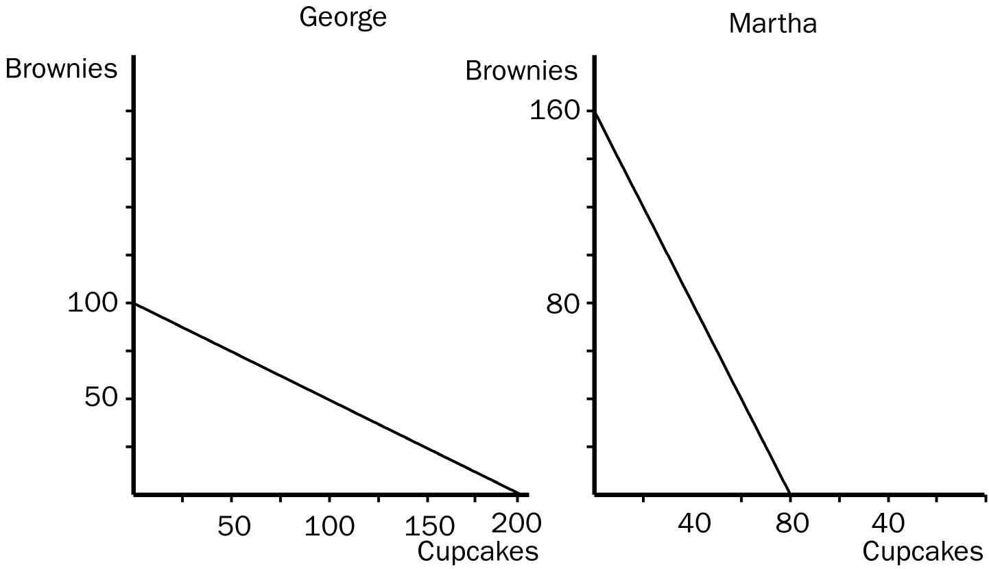

a. If George and Martha choose not to trade and divide their time equally between the production of brownies and cupcakes, how many of each would they be able to consume? (Show this point on your graphs.)
b. Now assume that George and Martha decide to specialize in the good in which they have a comparative advantage and then trade. Who would trade brownies and who would trade cupcakes?
c. If George and Martha decide to trade 60 brownies for 60 cupcakes, how many cupcakes and brownies would each have to consume?
d. How do we know each is better off with trade than acting alone?
ANSWER:

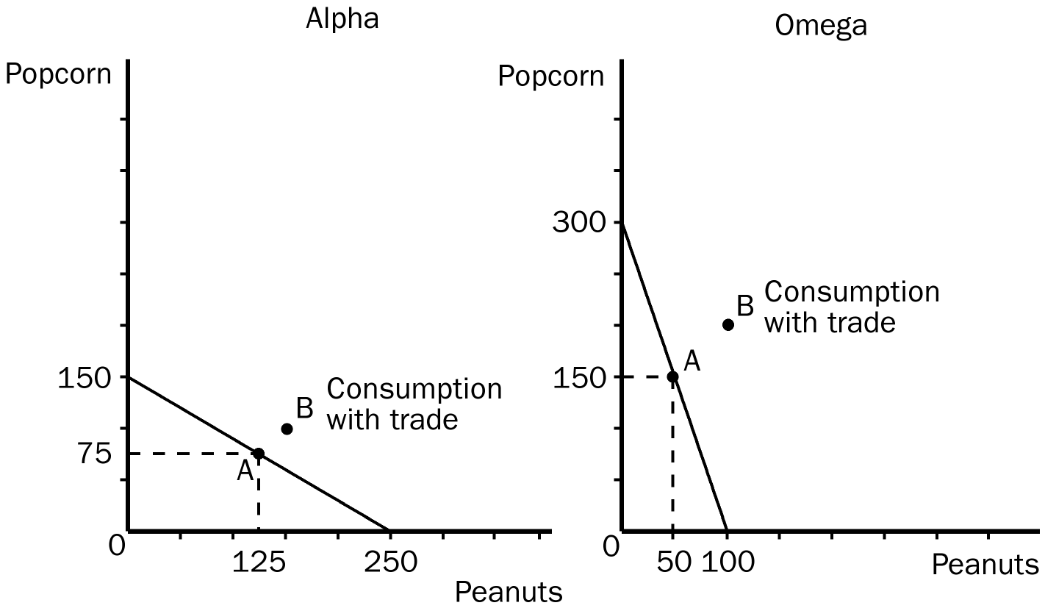

a. If George and Martha divide their time equally, George would be able to produce 50 brownies and 100 cupcakes (point A on his PPF) and Martha would be able to produce 80 brownies and 40 cupcakes (point A on her PPF).
b. George has a comparative advantage in and would trade cupcakes, Martha has a comparative advantage in and would trade brownies.
c. Since George is producing 200 cupcakes and no brownies, if he trades 60 cupcakes, he would be left with 140 cupcakes and would expect to receive 60 brownies from Martha in return. Since Martha is producing 160 brownies and no cupcakes, if she trades 60 brownies, she would be left with 100 brownies and would expect to receive 60 cupcakes from George in return.
d. We know that both George and Martha are better off with trade because both are able to consume outside their own production possibilities frontiers.
TYPE: S SECTION: 1
3. The only two countries in the world, Alpha and Omega, face the following production possibilities frontiers.

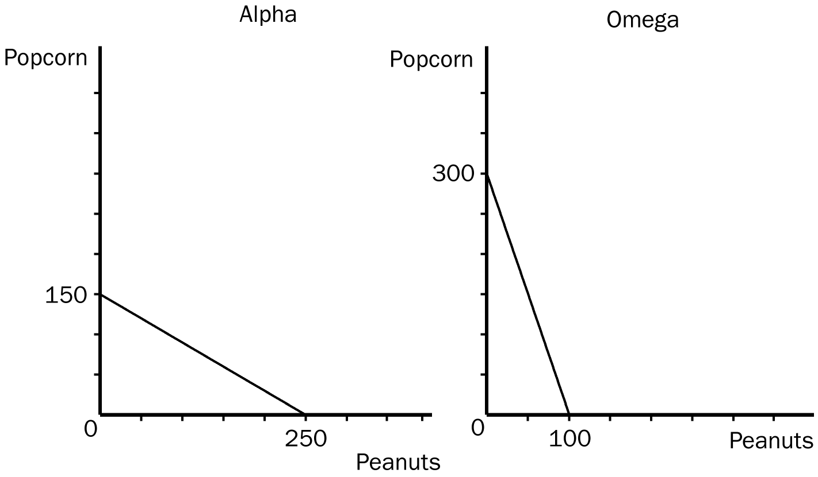

a. Assume that each country decides to use half of its resources in the production of each good. Show these points on the graphs for each country as point A.
b. If these countries choose not to trade, what would be the total world production of popcorn and peanuts?
c. Now suppose that each country decides to specialize in the good in which each has a comparative advantage. By specializing, what is the total world production of each product now?
d. If each country decides to trade 100 units of popcorn for 100 units of peanuts, show on the graphs the gain each country would receive from trade. Label these points B.
ANSWER:

a. Alpha would be producing 125 units of peanuts and 75 units of popcorn (point A on its PPF) and Omega would be producing 50 units of peanuts and 150 units of popcorn (point A on its PPF).
b. The total world production of peanuts would be 175 units and the total world production of popcorn would be 225 units.
c. The total world production of peanuts would now be 250 units and the total world production of popcorn would now be 300 units.
d. Alpha would be producing 250 units of peanuts and would trade 100 of them to Omega, leaving Alpha with 150 units of peanuts. Alpha would then receive 100 units of popcorn from Omega. Omega would be producing 300 units of popcorn and would trade 100 of them to Alpha, leaving Omega with 200 units of popcorn. Omega would then receive 100 units of peanuts from Alpha.
TYPE: S SECTION: 1
4. Julia can fix a meal in 1 hour, and her opportunity cost of one hour is $50. Jacque can fix the same kind of meal in 2 hours, and his opportunity cost of one hour is $20. Will both Julia and Jacque be better off if she pays him $45 per meal to fix her meals? Explain.
ANSWER: Since Julia’s opportunity cost of preparing a meal is $50, and Jacque’s opportunity cost of preparing a meal is $40, each of them will be better off by $5 per meal if this arrangement is made.
TYPE: S SECTION: 2
5. Gary and Diane must prepare a presentation for their marketing class. As part of their presentation, they must do a series of calculations and prepare 50 PowerPoint slides. It would take Gary 10 hours to do the required calculation and 10 hours to prepare the slides. It would take Diane 12 hours to do the calculations and 20 hours to prepare the slides.
a. How much time would it take the two to complete the project if they divide the calculations equally and the slides equally?
b. How much time would it take the two to complete the project if they use comparative advantage and specialize in calculating or preparing slides?
c. If Diane and Gary have the same opportunity cost of $5 per hour, is there a better solution than for each to specialize in calculating or preparing slides?
ANSWER:
a. If both tasks are divided equally, it will take 11 hours for the calculations and 15 hours for the writing, for a total of 26 hours.
b. If Diane specializes in calculating and Gary specializes in preparing slides, it will take 22 hours to complete the project.
c. If Diane specializes in calculating, her opportunity cost will be $60; hence, Diane would be better off if she paid Gary any amount less than $60 to do the calculating. Since Gary’s opportunity cost of doing the calculations is only $50, he would be better off if Diane paid him between $50 and $60 dollars to do the calculations. In this case, the total time spent on the project would be 20 hours.
TYPE: S SECTION: 2
6. Suppose that a worker in Taiwan can make 2 TVs or 10 pairs of shoes per week, and a worker in Korea can make 3 TVs or 20 pairs of shoes per week.
a. In what sense do TVs and shoes cost less in Korea than in Taiwan?
b. In what sense do TVs cost less in Taiwan than in Korea?
c. If Taiwan and Korea were to engage in trade, which country would export which good?
d. Would the answer to the above question change if a worker in Korea could make 4 TVs per week?
ANSWER:
a. In terms of labor time spent making TVs and shoes, both goods cost less in Korea than in Taiwan, 0.33 weeks per TV and 0.05 weeks per pair of shoes in Korea, and 0.5 weeks per TV and 0.1 weeks per pair of shoes in Taiwan.
b. In terms of opportunity cost, TVs cost less in Taiwan than in Korea: 5 pairs of shoes per TV in Taiwan and 6.67 pairs of shoes per TV in Korea.
c. Since Taiwan has a comparative advantage in TVs, it will export TVs. Since Korea has a comparative advantage in making pairs of shoes, it will export shoes.
d. Yes; no country would have a comparative advantage since opportunity costs will be the same for both countries.
TYPE: S SECTION: 3

